After Triggers fires after the triggering action. The INSERT, UPDATE and DELETE statements cause an after trigger to fire after the respective statements complete execution.

Instead of Triggers fires instead of the triggering action. The INSERT, UPDATE and DELETE statements cause an instead of trigger to fire instead of the respective statement execution.

# **After Triggers**

## **After INSERT Triggers**



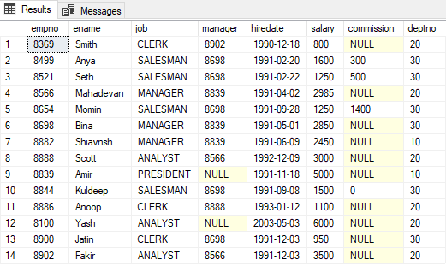



Inserting image...



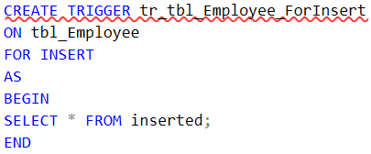







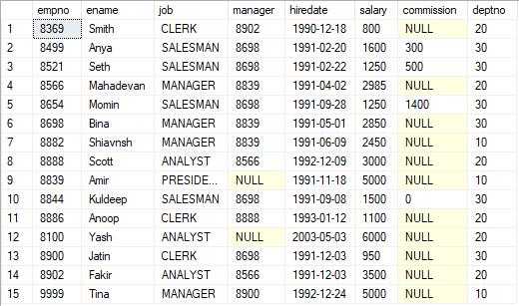

Inserted is a special table used by Triggers. This table is only available in the context of a Trigger.





The structure of the Inserted table is the same as the table on which the trigger has been made.

